Lab-6

Iris Classify

1. Import libraries:

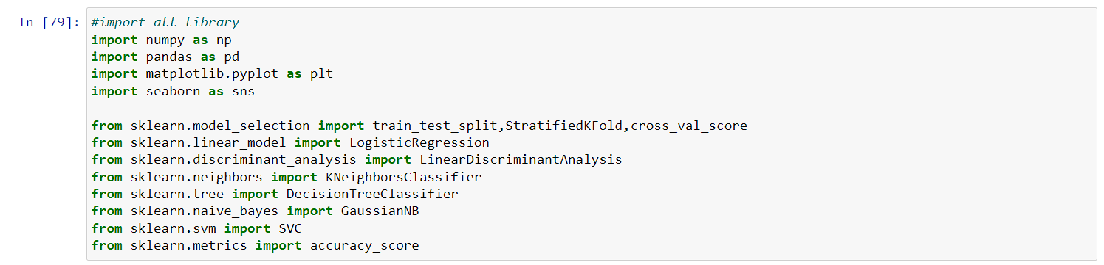

1. Loading the dataset.:

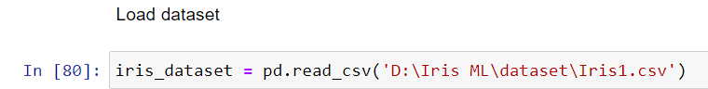

1. Summarizing the dataset:

* Dimensions of the dataset.

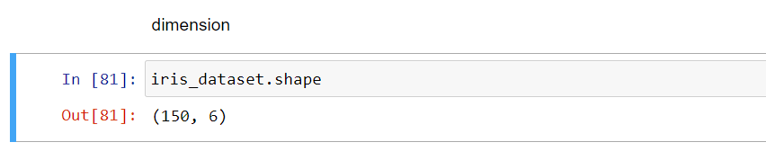

* Peek at the data itself.

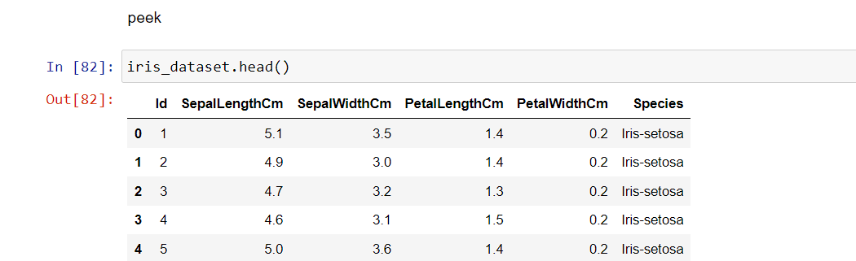

* Statistical summary of all attributes.

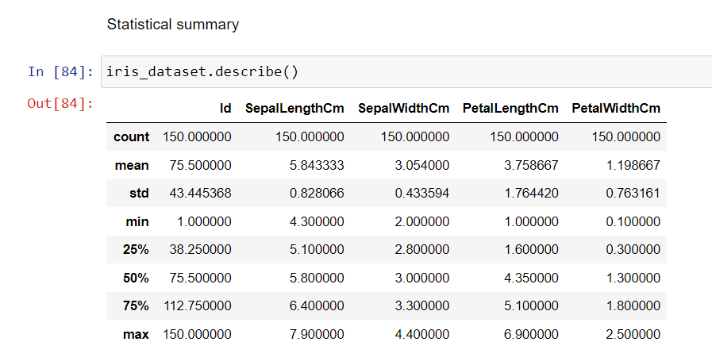

* Breakdown of the data by the class variable.

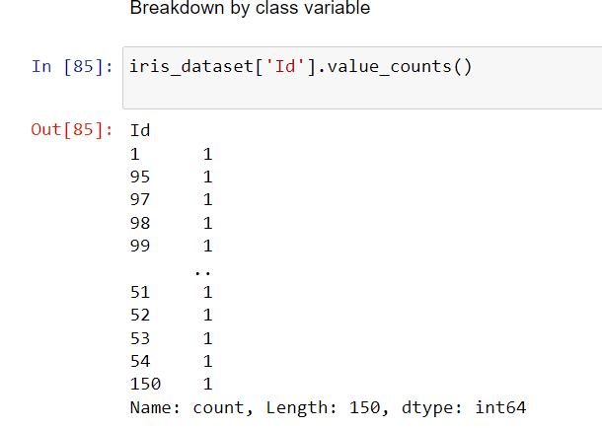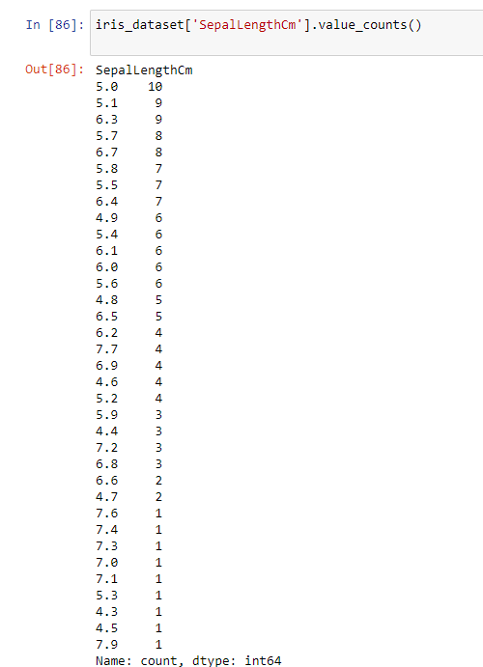

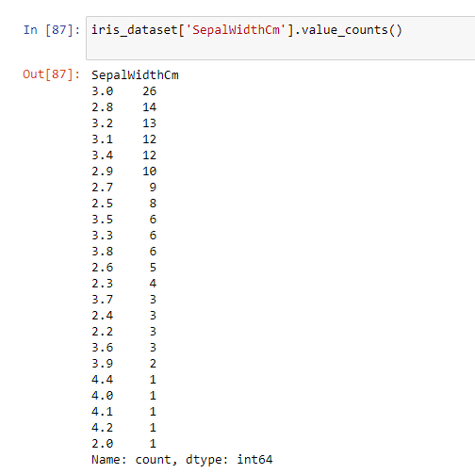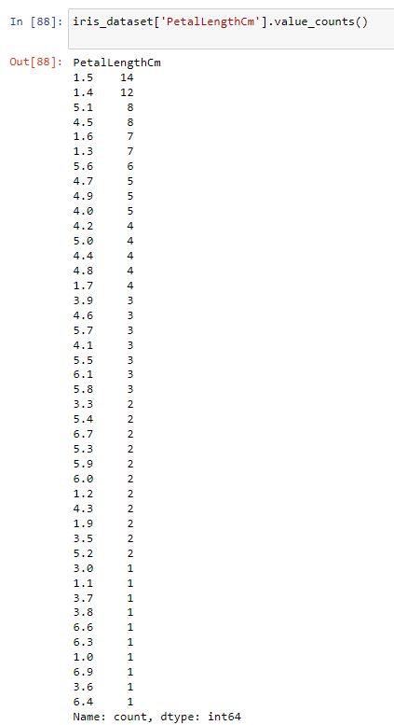

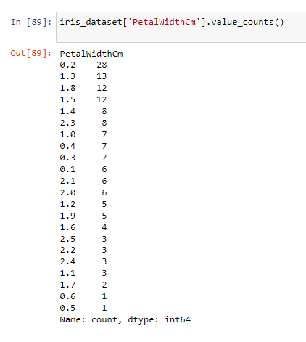

1. Visualizing the dataset.

* Univariate plots to better understand each attribute.

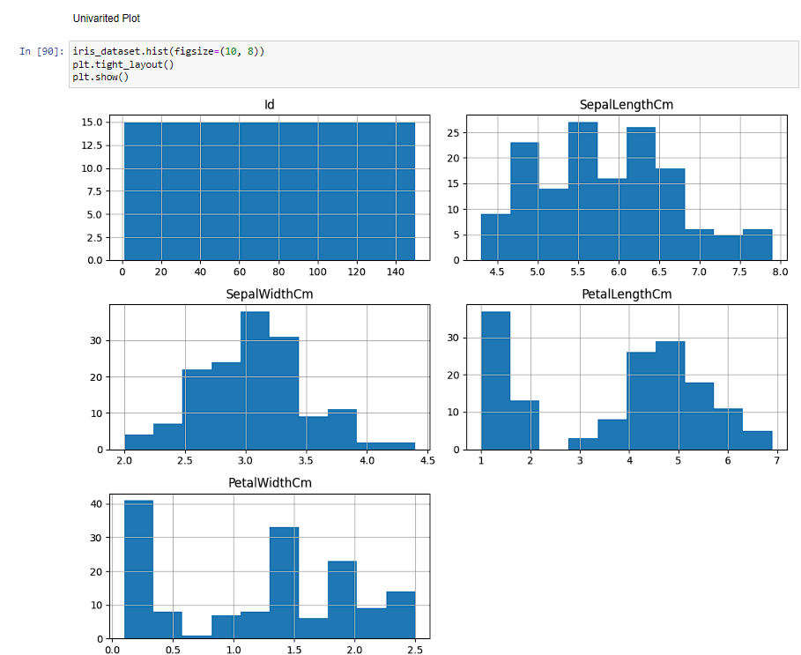

* Multivariate plots to better understand the relationships between attributes.

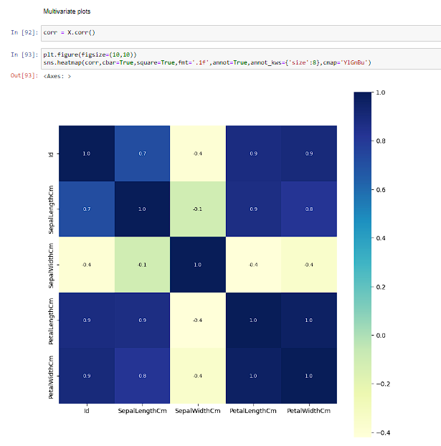

1. Evaluating some algorithms.

* Separate out a validation dataset.

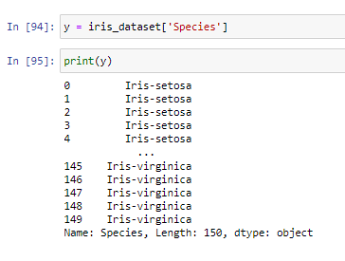

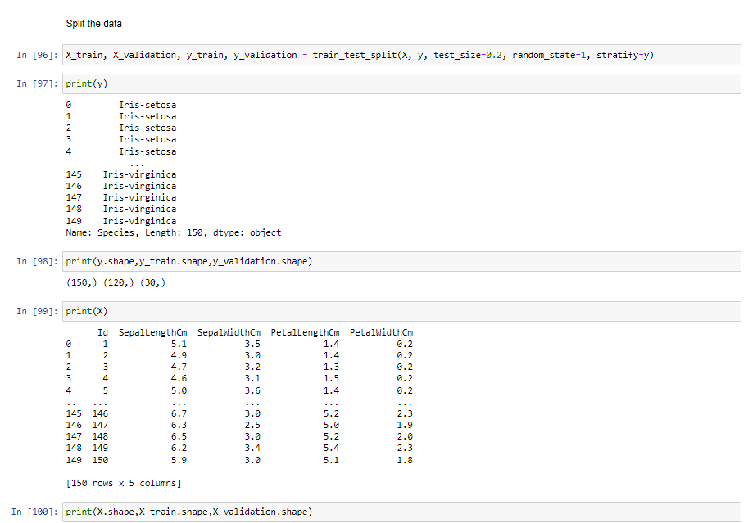

* Set-up the test harness to use 10-fold cross validation.

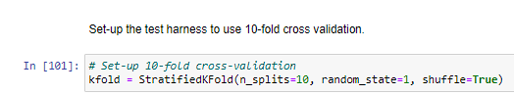

* Build multiple different models to predict species from flower measurements

1. Logistic Regression (LR)

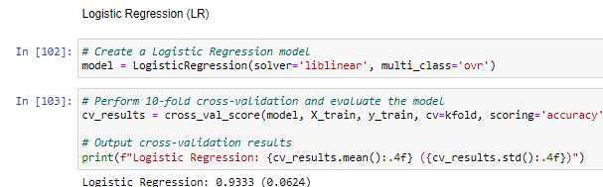

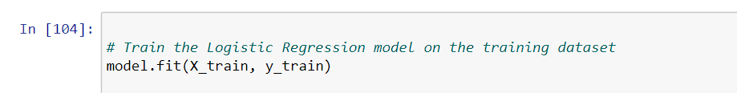



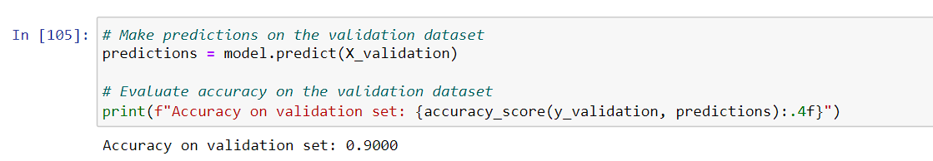

1. Linear Discriminant Analysis (LDA)

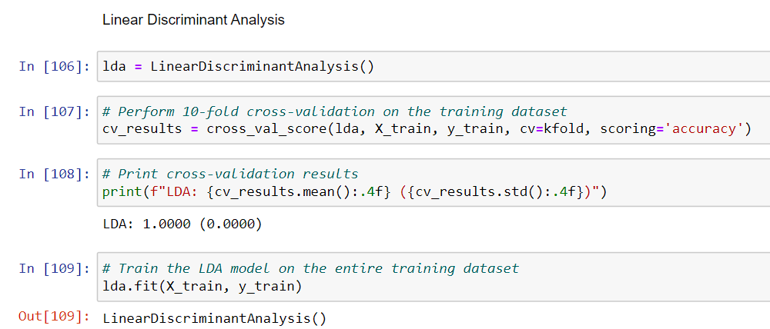

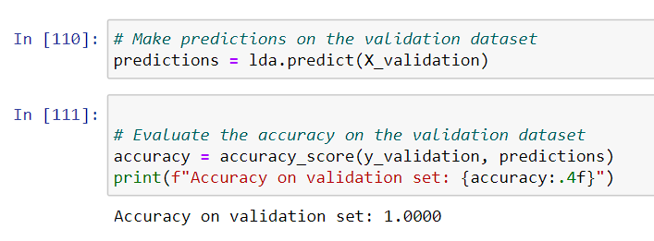

1. K-Nearest Neighbors (KNN).

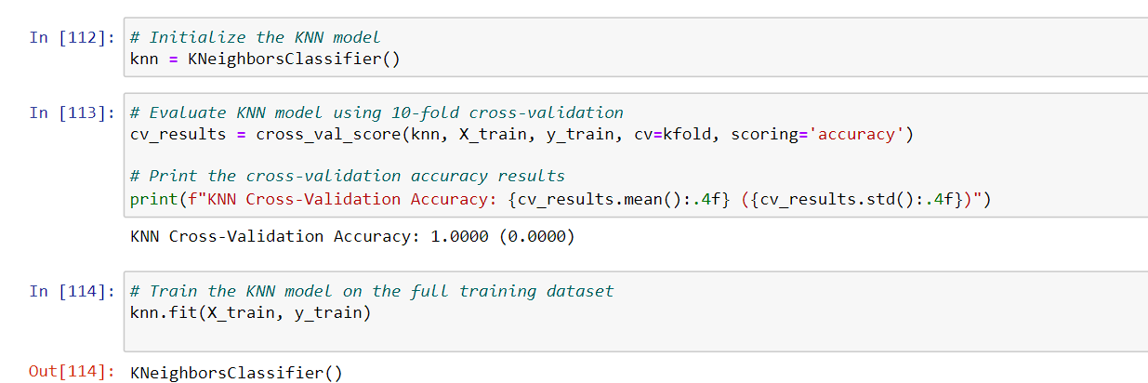

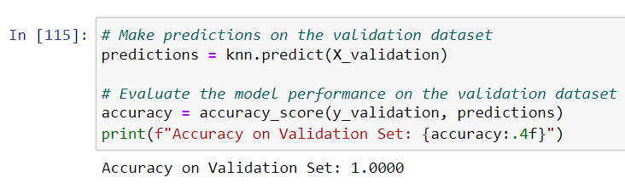

1. Classification and Regression Trees (CART).

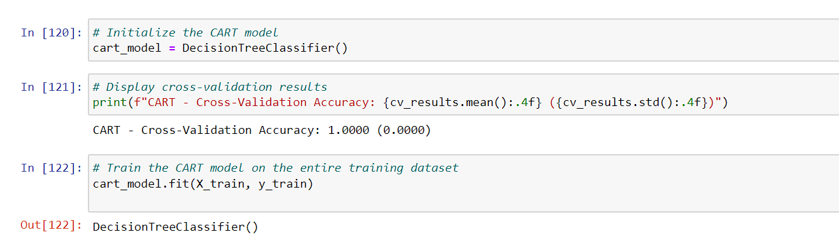

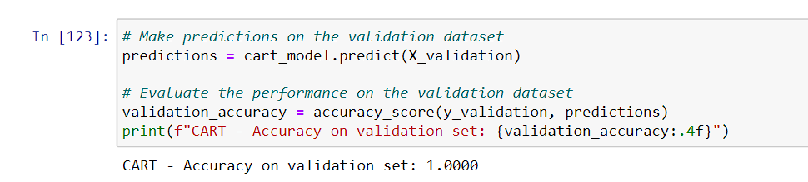

1. Gaussian Naive Bayes (NB).

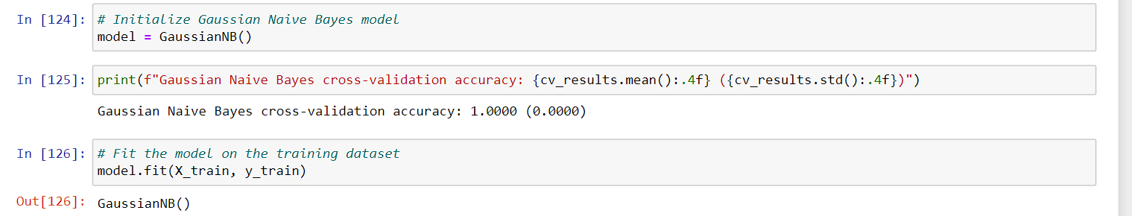

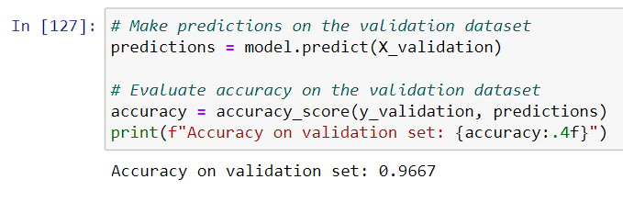

1. Support Vector Machines (SVM).

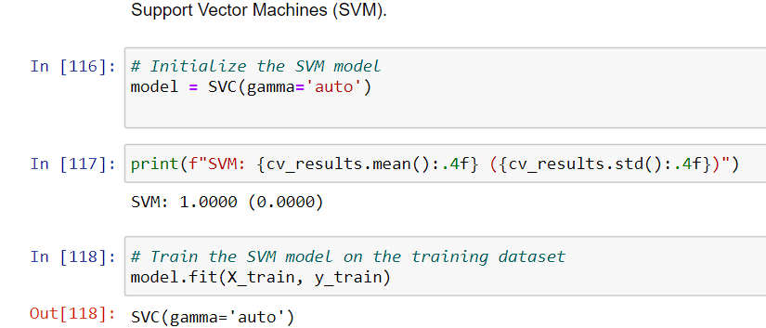

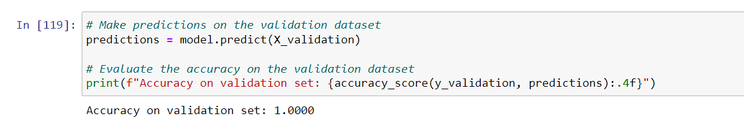

* Accuracy of the models:
* Logistic Regression (LR): **0.9000**
* Linear Discriminant Analysis (LDA):**1.000**
* K-Nearest Neighbors (KNN).**1.000**
* Classification and Regression Trees (CART).**: 1.000**
* Gaussian Naive Bayes (NB).**0.9667**
* Support Vector Machines (SVM).: **1.000**